Network Management and Automation

Lab 7

DevOps-Ansible, Automation, and Networking

University of Colorado Boulder

Network Engineering Program

Professor Levi Perigo, Ph.D.

# Summary

Automation is an important component to achieve new data center deployments in short time intervals. Data centers require similar type devices to be configured multiple numbers of times and automation eliminates human intervention process of logging into devices using a console for configuration purpose.

# Objectives

* Create Ansible playbooks using a Python script based on your network topology and the router configuration requirements.
* Create Jinja2 templates based on your final router configuration requirements.
* Create a final router configuration file using Ansible and a Jinja2 template.
* Learn to use Ansible, Jinja2, and Python to automate network deployments and device configurations.

Problem Statement:

In your previous labs, you worked on automating the complete network in your data center using Netmiko and you have also worked using Ansible for configuration and package management. In this lab, you will automate new routers deployment in your data center network using Python, Ansible playbooks, and Jinja2 templates.

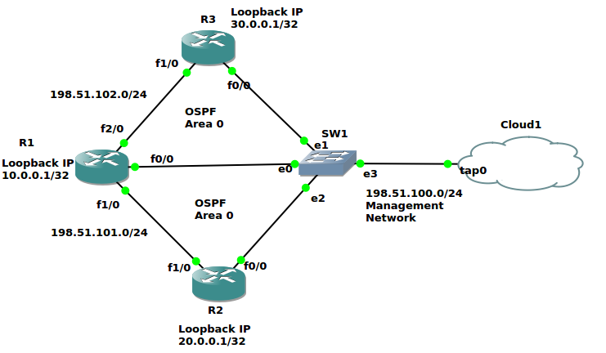

Figure 1

Guidelines:

Create the above-mentioned topology in GNS3 on the NetMan VM. Management network and SSH should be configured/enabled on R1, R2, and R3. Do not configure anything else manually.

Ansible and Jinja2 Help:

1. https://pynet.twb-tech.com/blog/ansible/ansible-cfg-template.html

Ansible Example:

Use Ansible Roles directory as the main directory containing Tasks, Templates, and Vars as subdirectories to deploy your automation. Refer to the above Ansible automation reference link for guidance. The below Ansible playbook examples are only for your reference and your Ansible playbooks generated using Python will not be exactly similar to these, they will contain additional elements according to the configuration requirements.

The following is the directory structure required. Follow the above reference link for more information.

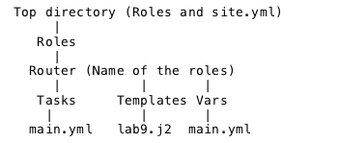

The following are two separate example YAML files. When the first file is executed, it will call the second variables containing file (created using Python). Follow the above reference link for more information.

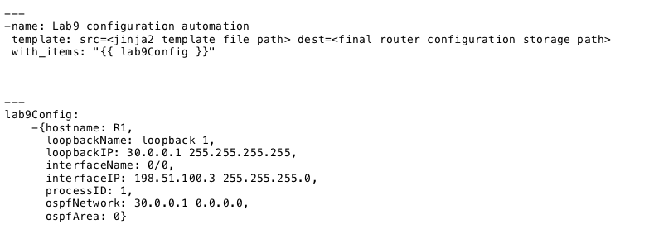

Jinja2 Example:

The below Jinja2 template example (lab9.j2) is only for your reference and your Jinja2 template will not be exactly similar to this, it will consist of additional elements according to the configuration requirements.

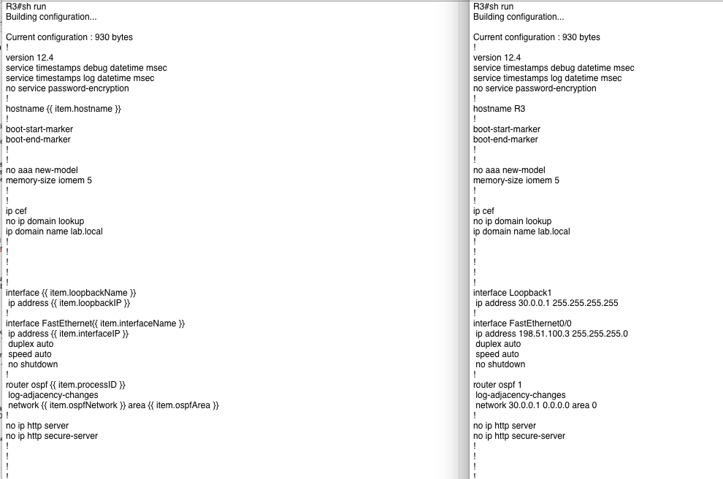

Lab configuration requirements:

|  |  |  |  |  |  |  |
| --- | --- | --- | --- | --- | --- | --- |
| Hostname | Interface Type | Interface Name | IP/Subnet | OSPF Enabled | OSPF Process ID | OSPF Area |
| R1 | Loopback | 1 | 10.0.0.1/32 | Yes | 1 | 0 |
| R1 | FastEthernet | 0/0 | 198.51.100.3/24 | Yes | 1 | 0 |
| R1 | FastEthernet | 1/0 | 198.51.101.3/24 | Yes | 1 | 0 |
| R1 | FastEthernet | 2/0 | 198.51.102.3/24 | Yes | 1 | 0 |
| R2 | Loopback | 1 | 20.0.0.1/32 | Yes | 2 | 0 |
| R2 | FastEthernet | 0/0 | 198.51.100.4/24 | Yes | 2 | 0 |
| R2 | FastEthernet | 1/0 | 198.51.101.4/24 | Yes | 2 | 0 |
| R3 | Loopback | 1 | 30.0.0.1/32 | Yes | 3 | 0 |
| R3 | FastEthernet | 0/0 | 198.51.100.5/24 | Yes | 3 | 0 |
| R3 | FastEthernet | 1/0 | 198.51.102.5/24 | Yes | 3 | 0 |

Objective 1: Using the given topology, create a Jinja2 template for the Cisco routers (R1, R2, and R3). Do not configure the Cisco routers in GNS3 in the NetMan VM manually. **[50 Points]**

Objective 2: Using the configuration requirements (CSV), create an Ansible playbook in YAML format with the help of a Python script. Follow the Ansible “Roles” directory framework for this objective. This Ansible playbook and Jinja2 templates for R1, R2, and R3 will be used to create the actual router configuration files to configure the above topology in GNS3 in your NetMan VM. **[50 Points]**

CSV File:

Ansible Playbook main.yaml (in vars directory):

playbookCreation.py:

R1,R2,R3 templates:

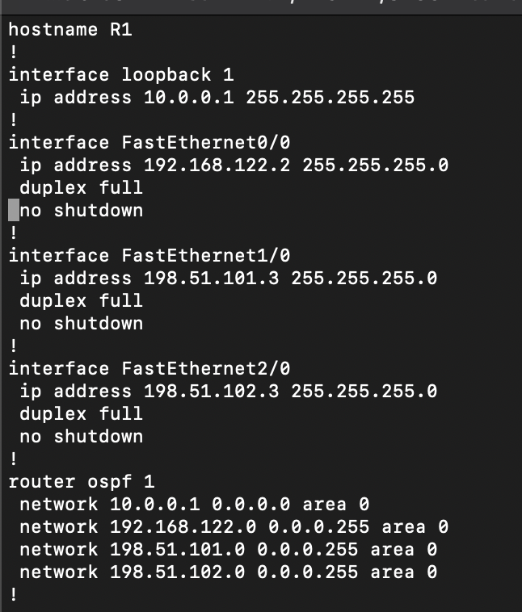

Objective 3: Configure R1, R2, and R3 in GNS3 in your NetMan VM using Netmiko and achieve complete reachability to the real and loopback interfaces of R1, R2, and R3 from your NetMan VM terminal. **[50 Points]**

playbookCreation.py:

Extra Credit I: Configure R1, R2, and R3 by pulling the new configuration file generated in Objective 2 using ZTP. Configure a DHCP server to also act as a TFTP server on your NetMan Ubuntu machine and configure R1, R2, and R3 as DHCP clients to request IP address and the new configuration file from Objective 2. Use below links for reference and also search the Internet for more help and reference. **[25 Points]**

**Use below links for ZTP reference,**

1. <https://www.digitalocean.com/blog/zero-touch-provisioning-how-to-build-a-network-without-touching-anything>
2. <https://www.cisco.com/c/en/us/td/docs/switches/lan/catalyst9500/software/release/16-5/configuration_guide/prog/b_165_prog_9500_cg/zero-touch_provisioning.pdf>

Report Questions:

1. After completing this lab, explain ZTP and when can ZTP be implemented in the real world with an example? **[10 points]**

ZTP or zero touch provisioning is the process of configuring a device with no interaction from the user. This process enhances the process of network automation by further abstracting the user from the device. ZTP can be implemented in large data centers when many devices are being put in at one time. A data center could use a system where the scan the RFID code on the box of the network device. This would give them valuable information like serial number and device type. Once the device is connected to the network, the information grabbed by the RFID can identify the device and configure it accordingly through ZTP.

Total Points ____________ / 160 (+25 extra credit)